Role of Technology in the COVID-19 Pandemic

INTRODUCTION

## Artificial Intelligence

As a scientific data mining tool in medical field: AI refers to any human – like intelligence exhibited by computer, robot, or other machine. As the pandemic has spread globally, there has been an influx of medical research published about Covid-19. While such a large volume of research is a potential boon to our understanding of how to control and treat the virus, it also presents Big Data challenges. So much research is difficult to distill and, therefore, can be difficult to draw conclusions from. Researchers are turning to AI to help them better mine data for insights.

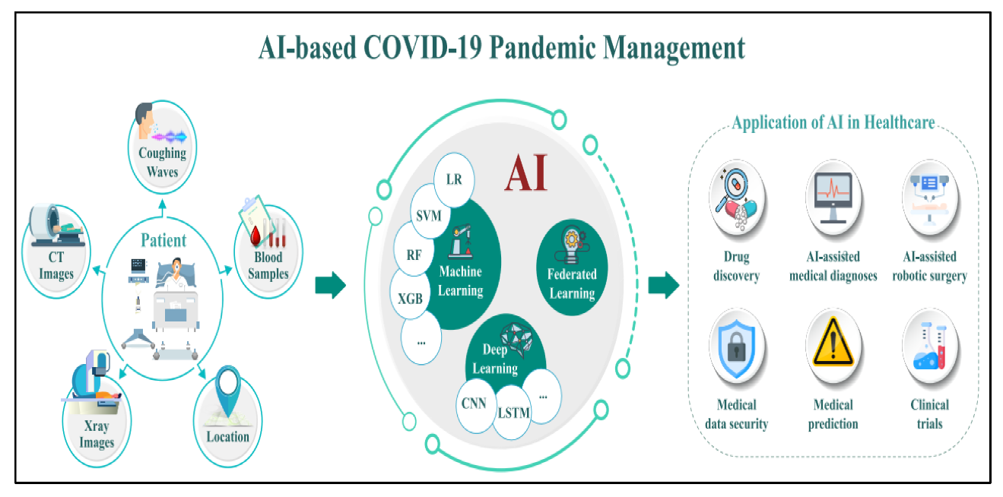

## Machine Learning

Benefits in eLearning Machine learning is a field of computer science that gives computers the capacity to learn without being directly explicitly programmed. Machine Learning is actively being used today, perhaps many more places one would expect. There is a range of benefits that Machine Learning can offer to online learners, as well as organizations that invest in LMS platforms. First of all, Machine Learning has the ability to offer more custom eLearning solutions based on the learner’s past performance and learning goals. Secondly, it enables efficient resource allocation since online learners receive the exact eLearning resources they require in order to fill knowledge gaps and accomplish their learning goals.

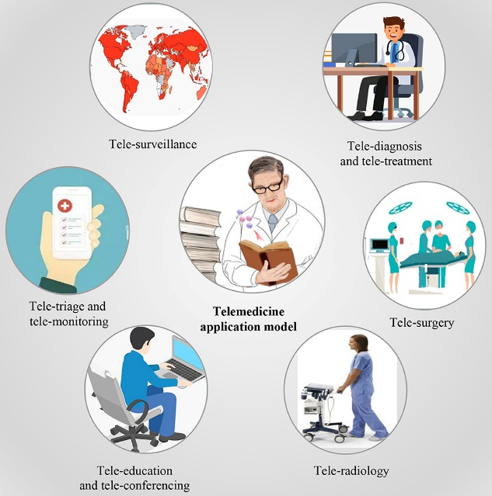

Virtual Reality

1. Reduce the direct spread of Virus:

VR technology develops a platform to reduce the face to face interaction of doctors with the infected COVID-19 patients. Through live video streaming, it helps to improve surveillance systems on the ongoing situation. Virtual reality modelling language , as an international standard of virtual reality, has been developing rapidly. VRML was first proposed by Rava Raggett of HP European Research Laboratory at the first World Wide Web VRML is a language technology to create virtual reality environment on the Web.

1. In Education and Business:

For experiential business, like tours or events, the use of cutting-edge technology in the form of virtual reality (VR) provides the most valuable experience because of its visualization and storytelling capabilities. Because it can require an investment in hardware, however, this technology has had the slowest adoption rate. Verticals are finding ways around that barrier, specifically education. Whether it’s low-touch – like video conference calls – or life-like experiences that require a VR headset, virtual tours and classrooms are quickly becoming the norm for students, from kindergarten to college .As it really gives a 3-dimensional real views due which to learning the things becomes interesting and easy for students.

# CONCLUSION

Never has the potential of AI , ML and VR been more clear than in this particular moment of crisis. During a pandemic, when time is of the essence, AI can help stem the tide of the virus by predicting outbreaks, serving as a triage tool, and helping researchers mine insights from huge swaths of data. Similarly machine learning plays a great role in the eLearning system. Whereas Virtual Reality (VR) has offered an imperative role for fighting this pandemic, through audiovisual-based virtual communication.

# REFERENCES

1. World Health Organization (WHO) - COVID-19 and Technology

2. Centers for Disease Control and Prevention (CDC) - COVID-19 and Technology

3. United Nations - COVID-19 and Technology